**Xonix**

The main idea is to develop the mechanic of the game Xonix.

With the ability to change the number of "enemies" and the percentage of the filled area to finish the game.

Use of any third-party plugins is prohibited.

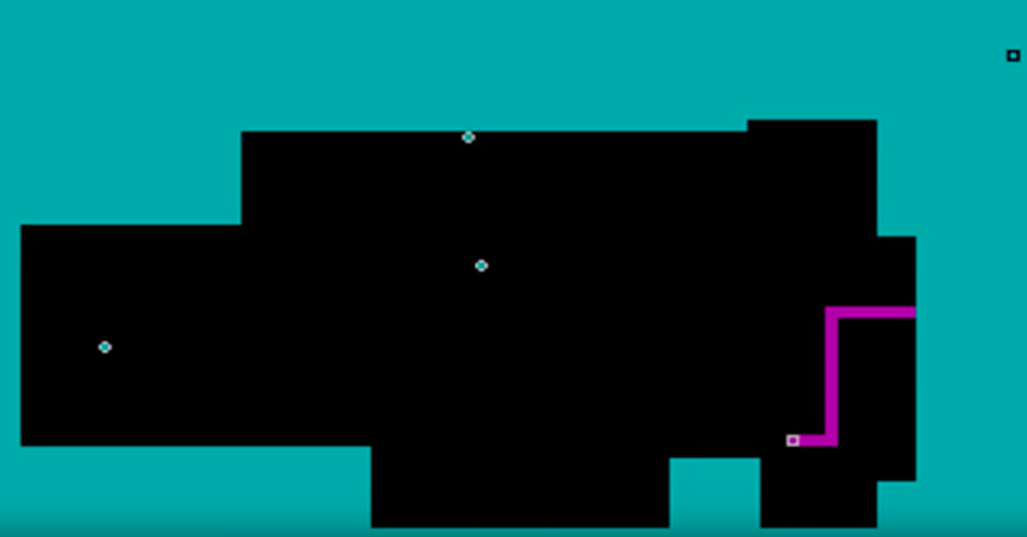

Unity version 2020.2.3f1 or higher.

Reference:

<https://www.youtube.com/watch?v=zJCbKPNEnF8>